Correlation between trust in government <br>and timing of the latest NDRP EOs.
(“National Defense Resources Preparedness Executive Orders”)

(Note: correlation does not necessarily imply causality)

NDRPEO 2012 Alarm:

http://www.huffingtonpost.com/jim-garrison/martial-law-under-another_b_1370819.html

NDRPEO 2012 No Big Deal:
We’re getting a lot of e-mail this weekend about an executive order issued on Friday afternoon by President Obama titled “National Defense Resources Preparedness.” While the timing of the EO is curious — why send it out on a Friday afternoon when an administration is usually trying to sneak bad news past the media? — the general impact of it is negligible. This EO simply updates another EO (12919) that had been in place since June 1994, and amended several times since
Again, this is almost identical to EO 12919 from 18 years earlier. Note what this EO specifically orders: identify, assess, be prepared, improve, foster cooperation. None of these items claim authority to seize private property and place them at the personal disposal of Obama. What follows after Section 103 are the directives for implementing these rather analytical tasks, mostly in the form of explicit delegations of presidential authority to Cabinet members and others in the executive branch.
http://hotair.com/archives/2012/03/18/national-defense-resources-preparedness-executive-order-power-grab-or-update/

NDRPEO 2012 greatly expands power of President:

Maggie is a Conservative, reporting on Jay Sekulo’s take on NDRPEO 2012

http://www.maggiesnotebook.com/2012/03/jay-sekulow-obama-ndrp-changes-definition-of-national-defense-goes-farther-much-broader-powers-than-any-other-similar/

Jay Sekulo is Chief Council for the American Center for Law and Justice: A conservative organization
http://aclj.org/

8888888888888888888888888888888888888888888888888888888888888888888

Some data correlating trust in government and the timing of the latest NDRP EOs:
(Note: correlation does not necessarily imply causality)

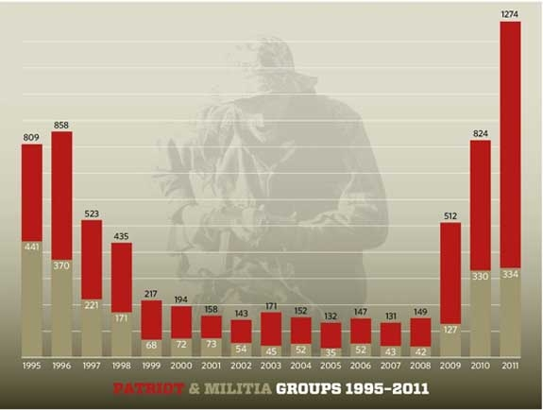

Data from:
http://www.splcenter.org/get-informed/intelligence-report/browse-all-issues/2012/spring/the-year-in-hate-and-extremism

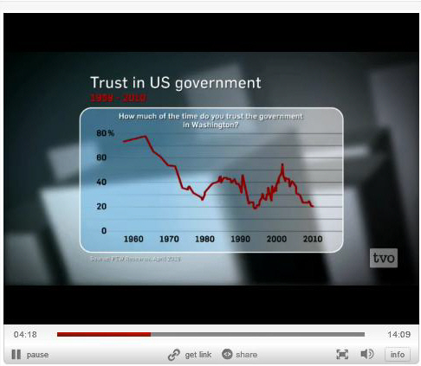

On Friday May 13, Steve Paikin interviewed Jonathan Kay, author of the book Among the Truthers, on the Canadian Agenda broadcast. This image was presented by Kay as evidence of the effect of “conspiracy theories”. A short version of the interview (14 minutes) is available on the Agenda website:

http://www.tvo.org/cfmx/tvoorg/theagenda/index.cfm?page_id=7&bpn=109161&ts=2011-05-13%2020:00:00.0

Note the correlation between the data on patriot and militia groups from SPLC and Kay’s data:

In the mid 1990’s (94-96) Kay’s US trust in government was at a minimum, while the number of patriot and militia groups was at a maximum of around 858. Note also that 1994 was the last issued NDRP EO.

Trust in government continued to increase during the 1990s, with a little oscillation around 1998, reaching a relative maximum (55 %) around 2001-2003. Since that time trust in government has continued to drop through 2010, to the 1994 level, of about 20%. The number of patriot and militia groups were at a minimum between 1999 and 2008, but then exploded beginning in 2008, reaching a record 1274 in 2011. Note the latest NDRP EO was March 2012.

