Revised 5/16/2011

Canadian Agenda’s Steve Paikin interviews Jonathan Kay, author of Among the Truthers

On Friday May 13, Steve Paikin interviewed Jonathan Kay, author of Among the Truthers, on the Canadian Agenda broadcast. The program will be rebroadcast on Monday May 16. A short version of the interview (14 minutes) is available on the Agenda website:

http://www.tvo.org/cfmx/tvoorg/theagenda/index.cfm?page_id=7&bpn=109161&ts=2011-05-13%2020:00:00.0

A critique of the 14 minute interview:

As with most true believers, Mr. Kay is heavy on psychology but light on fact in this interview, which discusses his book Among the Truthers.

The book, while ostensibly dealing with a variety of outlandish beliefs which question the credibility of the federal government,
places “truthers”, referring to those who doubt the official story on 9/11, squarely in the crosshairs. The label of “conspiracy theory” is applied to immediately discredit all of them without further consideration, which merely means these are perspectives we are not supposed to think about, regardless of the facts.

A video clip is presented showing someone who has been ostracized by everyone around him because of his conspiratorial beliefs. This is a personal warning to the viewer of the dangers of “conspiracy theories.”

One piece of apparently factual information which Mr. Kay provides is a graph showing percentage of public trust in government plotted by year from 1960 to 2010.

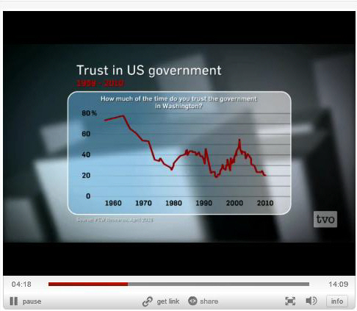

From: http://www.tvo.org/cfmx/tvoorg/theagenda/index.cfm?page_id=7&bpn=109161&ts=2011-05-13%2020:00:00.0

The plot shows that with ups and downs, public trust plummeted again around 2001.

This phenomena is again treated in a psychological way: conspiracy theories erode public trust, which in turn generates more conspiracy theories. Mr. Kay fails to make a rather obvious connection, which is the activity of the federal government during this time period: fictions about “weapons of mass destruction” used as a pretext to invade Iraq; the patriot act, which has eroded civil liberties, including secretive spying on innocent citizens ; the use of torture and indefinite detention; the lack of any meaningful response in the wake of Hurricane Katrina, the increasing resource gap between the rich and every one else, government and elections increasingly controlled by big money and big corporations, and little change in direction even with a new administration . Are these actions deserving of trust? Or are these all conspiracy theories?

Considering the emphasis Mr. Kay places on psychology, he makes a rather obvious omission, which is a consideration of tribal mind in his discussion: the average tribe member usually experiences a great deal of internal distress in questioning the authority of the tribal leader, or in this case the federal government. It is considered taboo, or unpatriotic, regardless of moral standing of the authority, which for this reason is usually given the benefit of the doubt . However, fact is fact, and when the disparity between the authority’s claims and perceived facts (called cognitive dissonance) reaches high enough levels, “conspiracy theories” which are true may arise.

Fair Use Notice

